
ANALYSIS OF DESIGN AND ALGORITHMS LAB

ASSIGNMENT-2

Submitted by: MANYA YADAV
Course : B.Tech CSE Data Science
Semester : IV
Roll No : 2401420012
Submitted To: Aarti Sangwan

TASK 1: DIVIDE AND CONQUER ALGORITHMS
CODE:
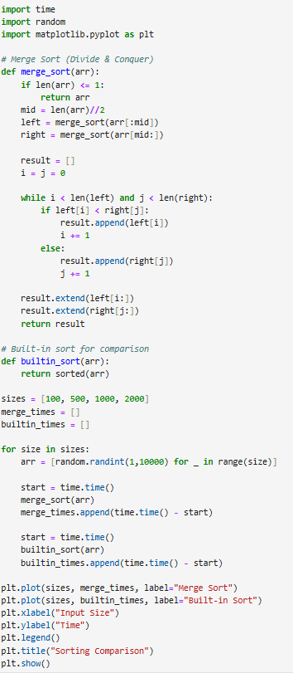
OUTPUT:
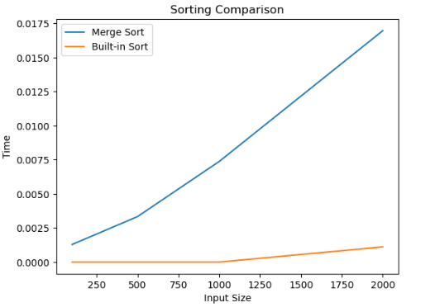

Observation
Merge Sort follows Divide & Conquer strategy
Time Complexity = O(n log n)
Built-in sort is faster due to optimization
As input increases, time increases gradually

TASKK 2:SORTING PERFORMANCE COMPARISON
CODE:

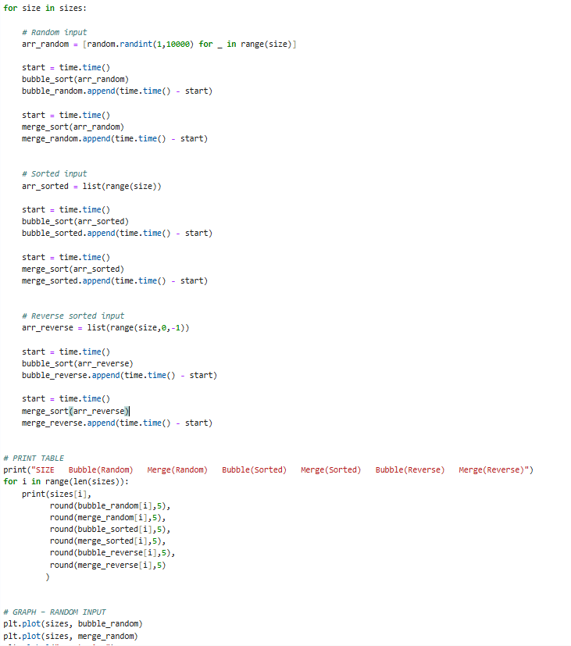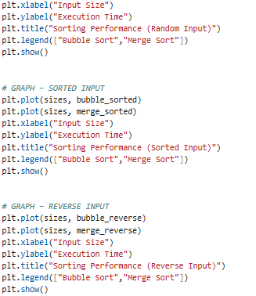
OUTPUT:

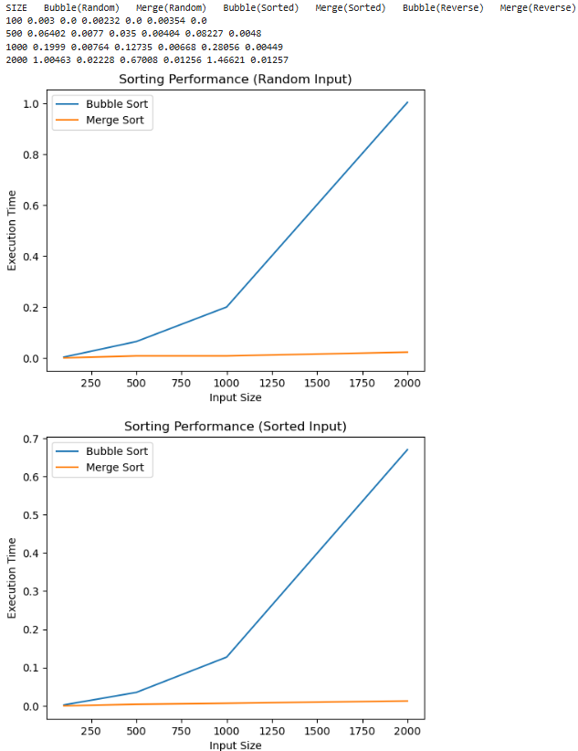
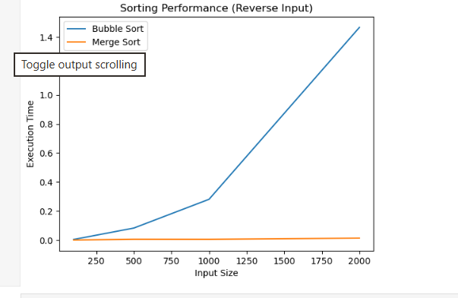
Observation:
- Bubble Sort performs well only for small input sizes.
- Its execution time increases very rapidly for large inputs.
- Merge Sort performs consistently for all types of input.
- Bubble Sort performs faster for sorted input compared to random input.
- Merge Sort execution time remains almost the same for sorted, random, and reverse input.
- Therefore, Merge Sort is more efficient for large datasets.

TASK 3: GREEDY ALGORITHMS
CODE:
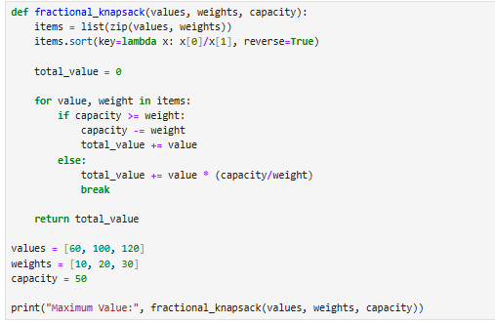
OUTPUT:

Observation
- Greedy chooses locally optimal solution
- Works efficiently for Fractional Knapsack
- Time Complexity: O(n log n) (due to sorting)

TASK 4:DYNAMIC PROGRAMMING FUNDAMENTALS
CODE:
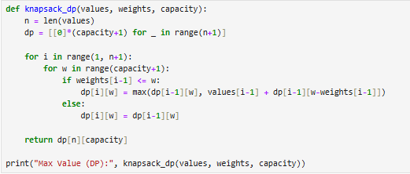
OUTPUT:

Observation
- Uses optimal substructure + overlapping subproblems
- More accurate than greedy for 0/1 case
- Time Complexity: O(n × capacity)

TASK 5:TRAVELLING SALESMAN PROBLEM
CODE:
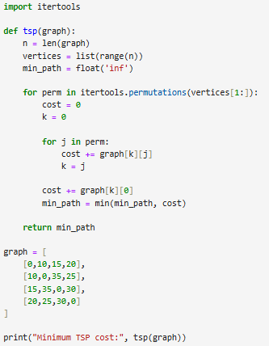
OUTPUT:

Observation
- Time Complexity = O(n!)
- Shows exponential growth
- Not practical for large inputs
GITHUB LINK: https://github.com/okayyymy15/MANYA_YADAV_ADA_ASSIGNMENTS

